**Best WordPress Development Company in Noida**

A powerful website is the foundation of a successful online presence. RS Organisation stands as the **best WordPress development company in Noida**, offering robust, scalable, and performance-oriented WordPress solutions. Whether you need a personal blog, e-commerce platform, or corporate website, our team delivers fully customized designs with high SEO value. Trust RS Organisation for seamless development, migration, and ongoing support to enhance your brand’s digital identity.

**Trusted WordPress Development Agency in Noida**

As a leading **WordPress development agency in Noida**, RS Organisation delivers tailored solutions that blend aesthetics, speed, and functionality. Our experienced developers and designers work closely with you to create websites that reflect your brand, drive engagement, and support conversions.

We specialize in building responsive websites that are mobile-friendly, SEO-ready, and user-centric. From startups to large enterprises, our WordPress development services in Noida cover every industry vertical with precision.

Client Logo add section add hoga jise Home page pe h

**Comprehensive WordPress Development Services in Noida**

We provide end-to-end **WordPress development services in Noida** that go beyond simple site creation. Our team focuses on creating interactive, secure, and optimized digital platforms that cater to your business goals. Whether you're building from scratch or upgrading an existing site, we ensure clean coding, fast load speeds, and a hassle-free user journey.

**Our Core Services Include:**

* Custom WordPress Theme & Plugin Development
* WooCommerce Store Setup & Integration
* Website Migration & Speed Optimization
* SEO-Ready Site Architecture
* Post-Launch Maintenance & Support
* Security, Backup, and Performance Enhancements

**Our WordPress Website**

[**https://www.imgglobalinfotech.com/web-development.php**](https://www.imgglobalinfotech.com/web-development.php)

**Yaha pe aisa section add karenge jo reference pe diya hua or client k naam k saath website show karenge ok**

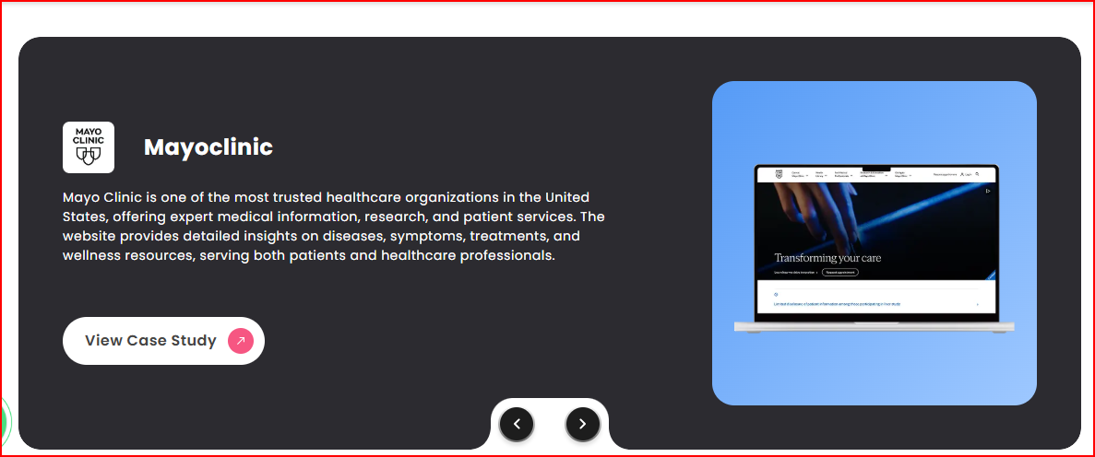

**Our WordPress Development Process**

Here’s a glimpse into our systematic 6-step WordPress development workflow at RS Organisation:

**1. Requirement Analysis**

We start by understanding your vision, goals, and business objectives. This helps us define a detailed project roadmap. We gather insights about your target audience, desired functionalities, and design expectations. This phase ensures that our output aligns perfectly with your brand identity and technical needs.

**2. Wireframing & UI/UX Design**

Our UI/UX experts create wireframes that illustrate the page structure, followed by design prototypes. This ensures that every page of your website provides an intuitive and delightful user experience. We use tools like Figma and Adobe XD to craft designs that reflect your brand tone and improve engagement.

**3. WordPress Theme Development**

After finalizing the design, our developers begin with custom theme development. Using lightweight code and the latest standards, we ensure high performance and responsiveness. Whether you need a minimalist design or a vibrant layout, we deliver pixel-perfect results optimized for all devices.

**4. Plugin Integration & Customization**

We integrate essential plugins to expand your website’s functionality. From form builders to SEO tools and security add-ons, every feature is configured to support your goals. If needed, we develop custom plugins that are secure, scalable, and tailored specifically to your needs.

**5. Testing & Quality Assurance**

Before launch, we perform extensive testing — covering compatibility, responsiveness, security, and speed. Bugs, if any, are resolved immediately. We ensure that the website runs flawlessly on all major browsers and devices, guaranteeing a consistent experience for all visitors.

**6. Launch & Ongoing Support**

Once the site is approved, we deploy it on your preferred hosting platform. Post-launch, our support team provides ongoing maintenance, timely updates, and technical assistance. We also monitor your website for uptime, performance, and backup health to keep it in peak condition.

Technologies We Use section add hoga Jise home page pe h

**Why Choose RS Organisation?**

RS Organisation is not just a **WordPress development company in Noida** — we’re your long-term digital partner. Our expertise, innovation, and commitment to quality set us apart from the rest.

**🏆 WordPress Customization Experts Noida**

Our team is made up of skilled professionals recognized as **WordPress customization experts in Noida**. We don’t just use themes — we tailor every element to match your unique business objectives and aesthetic needs.

**💼 Tailor-Made WordPress Solutions**

Whether it's a corporate site or an e-commerce store, we build **custom WordPress solutions in Noida** that are scalable and future-ready. Our modular approach helps businesses expand functionality over time without redesigning the core.

**🛒 WooCommerce Development Specialists**

Looking to build an online store? We specialize in **WooCommerce development in Noida**, creating high-converting e-commerce platforms with features like cart integration, payment gateways, inventory management, and customer tracking.

**🔄 Safe & Fast Website Migrations**

Our **WordPress migration services in Noida** ensure your existing website is moved to WordPress safely and without downtime. We take care of content transfers, database syncing, and SEO settings so you don’t lose your search rankings.

**🌐 Full-Stack Web Development Team**

As a holistic **web development company in Noida**, we offer solutions that go beyond WordPress — from hosting setup and SSL implementation to website security and lead generation tools.

**Industries We Serve**

**Google review**